QUANTUM SCATTERING REPORT
Yifeng CHEN
999016959

Part 1 — Free Gaussian wave packet
The free Gaussian wave model is,
ψ(0,x) = (2a/π)¹ᐟ⁴ exp[−a(x−x₀)²] exp[i p₀(x−x₀)].
To propagate the packet, the initial state is first transformed to momentum space,
Φ(p) = 1/√(2π) ∫ dx ψ(0,x) exp(−ipx).
With m=ℏ=1, each free-particle momentum component gains the phase exp(−ip²t/2). Transforming the components back to position space gives
ψ(t,x) = 1/√(2π) ∫ dp Φ(p) exp(ipx) exp(−ip²t/2).
This is the expression used to calculate the time snapshots in Figure 3.

1.1 Changing the width
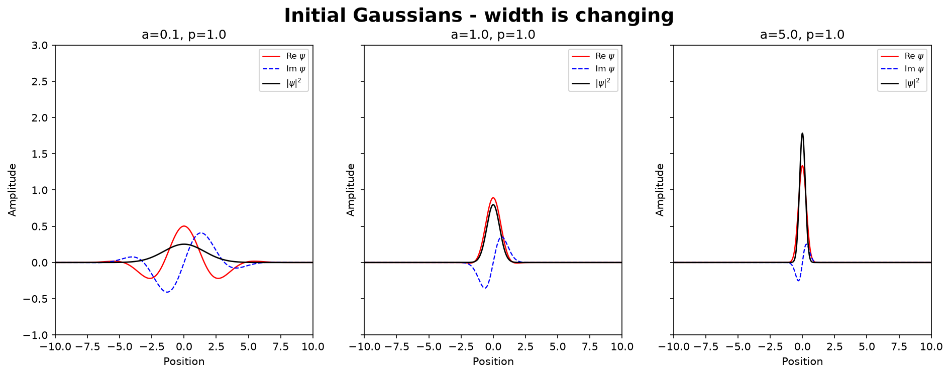
Figure 1. Initial Gaussian states for a = 0.1, 1, and 5 with p₀ = 1.
Here p0 = 1 is fixed, increasing a makes the probability distribution narrower in real space, and also the wave is narrower. This is because Δx=1/(2√a) at t=0.

1.2 Changing the mean momentum
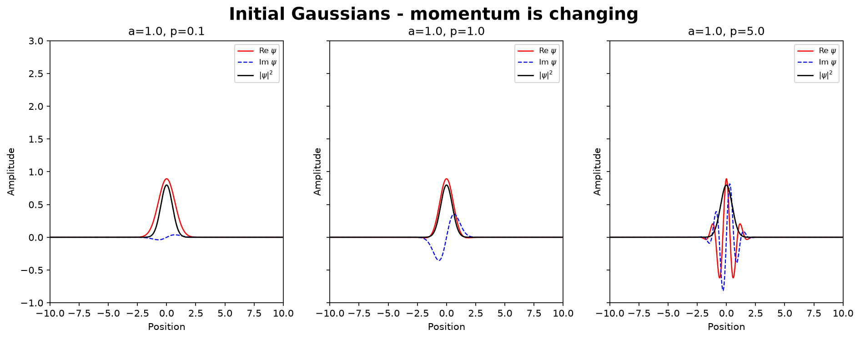
Figure 2. Initial Gaussian states for p₀ = 0.1, 1, and 5 with a = 1.
When a is fixed, a larger p₀ makes the real and imaginary parts oscillate more rapidly inside the same envelope. However, the Gaussian probability distribution, |ψ|², is unchanged when p₀ is varied.

1.3 Free propagation
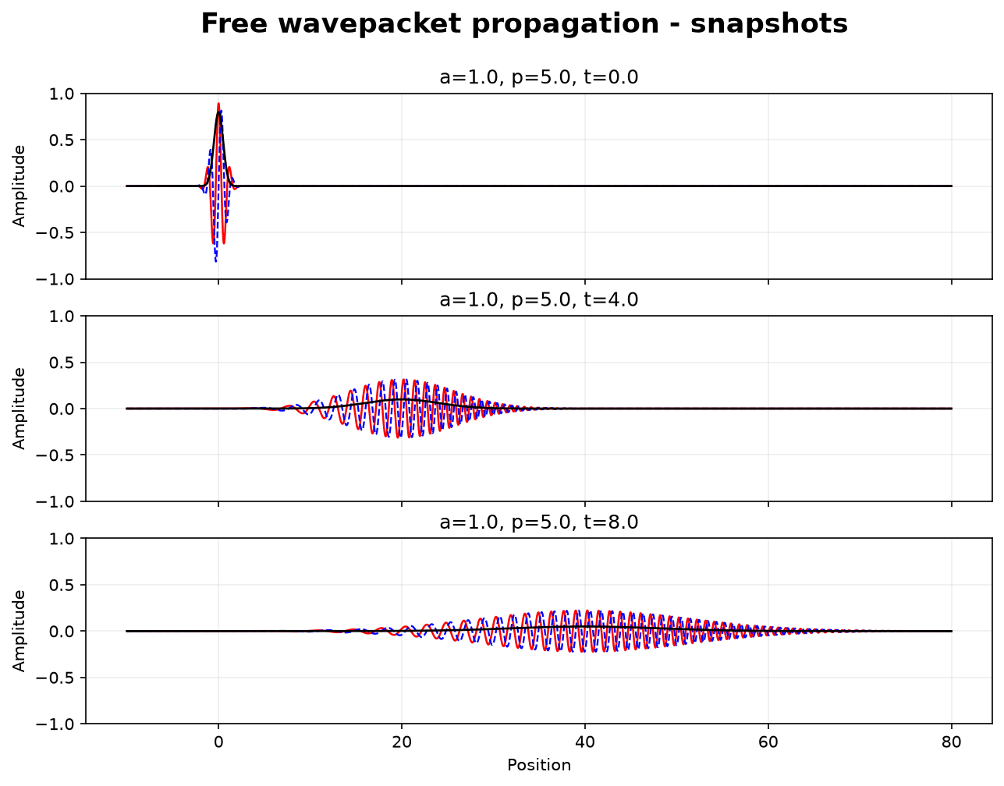
Figure 3. Free propagation for a = 1 and p₀ = 5 at t = 0, 4, and 8.
For t>0, the whole Gaussian wave moves to the right with a center velocity equaling p₀/m. At the same time the packet also spreads, so the Gaussian wave also becomes wider as time increase.

Part 2 — Regularized Dirac delta function
The approximation function of Dirac delta function used in the project is
δL(p) = sin(Lp)/(πp).

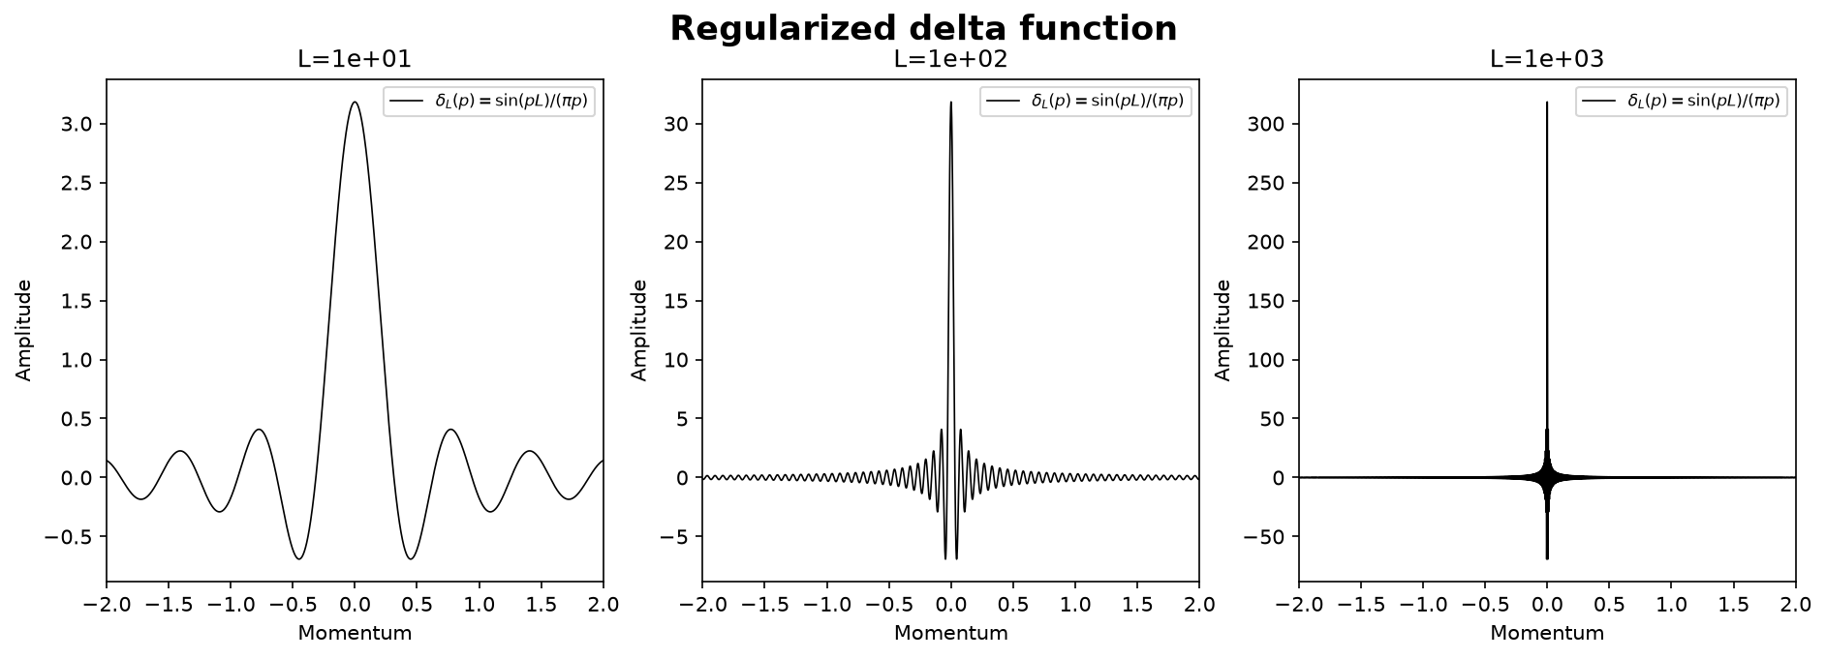
Figure 4. Finite-cutoff delta functions for L = 10, 100, and 1000.
As L increases, the central peak becomes higher and narrower and the side oscillations become more rapid.

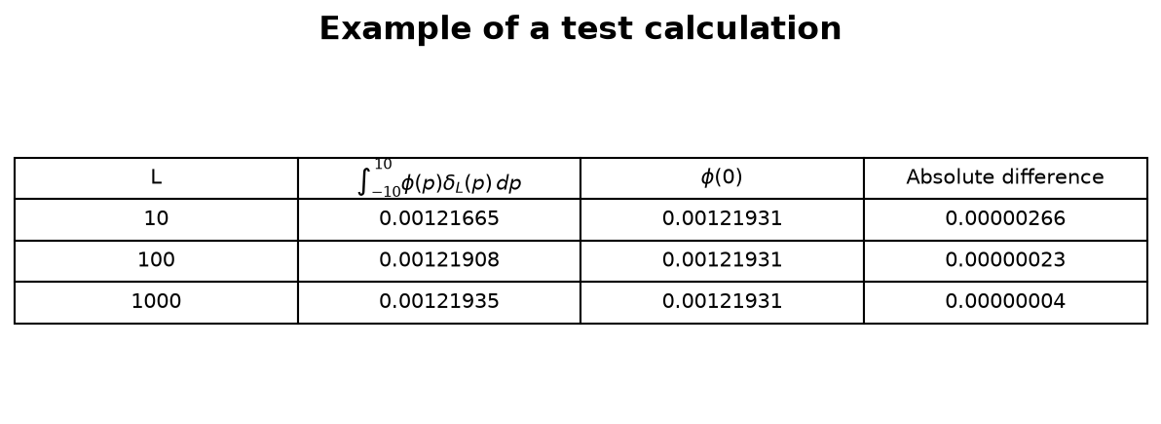
Figure 5. Numerical test of ∫ φ(p)δL(p) dp on the fixed interval [−10,10].
The target value is φ(0) = 0.0012193111. The absolute difference decreases from 2.66×10⁻⁶ at L = 10 to 2.26×10⁻⁷ at L = 100 and 3.70×10⁻⁸ at L = 1000. This confirms the expected delta-function behavior for the chosen smooth test function.

Part 3 — Stationary scattering and resonances
The scattering calculation uses the symmetric double-barrier potential:
V(x) = (x²/2 − 0.8) exp(−0.1x²),
which forms a central well between two barriers.
For a chosen energy E, the free-region momentum is k=√(2E). The calculation starts on the right with a modified state containing only the outgoing wave,
ψ̄E(x→+∞) = exp(ikx).
The finite-difference Schrödinger equation is then used to propagate this state from right to left. On a grid with spacing Δx,
ψ̄E(xₙ₋₁) = [2 + 2(Δx)²(V(xₙ)−E)] ψ̄E(xₙ) − ψ̄E(xₙ₊₁).
In the left free region, the numerical state is written as
ψ̄E(x→−∞) = A(E) exp(ikx) + B(E) exp(−ikx).
Dividing by A(E) makes the incoming amplitude equal to one,
ψE(x) = ψ̄E(x)/A(E),
so the transmission and reflection amplitudes are
T(E) = 1/A(E), R(E) = B(E)/A(E).
Repeating this calculation over E gives the probabilities |T(E)|² and |R(E)|². The two resonance energies discussed below are found from the peaks of the transmission spectrum.
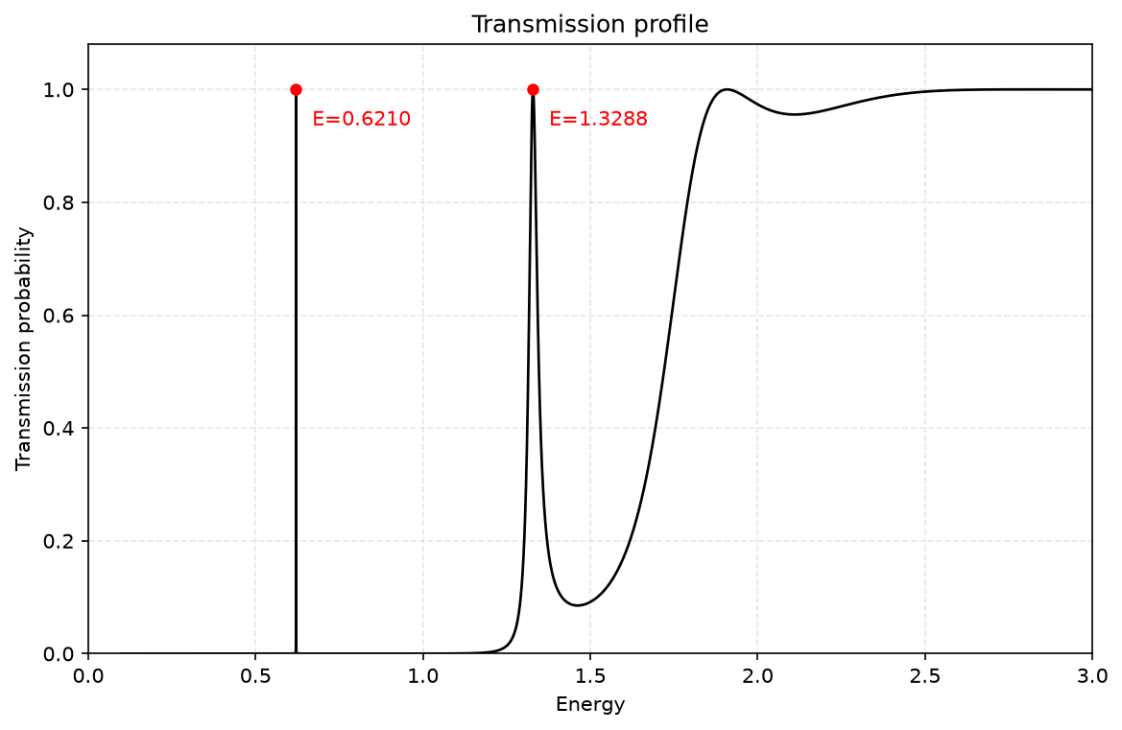
Figure 6. Transmission probability over 0 < E < 3.
The finite-difference maxima occur at E₁ ≈ 0.62097030 and E₂ ≈ 1.32882395. At both resonances, the transmission probability reaches almost one. The first peak is much narrower than the second, while at higher energies the transmission gradually approaches one.

3.1 Resonance peaks
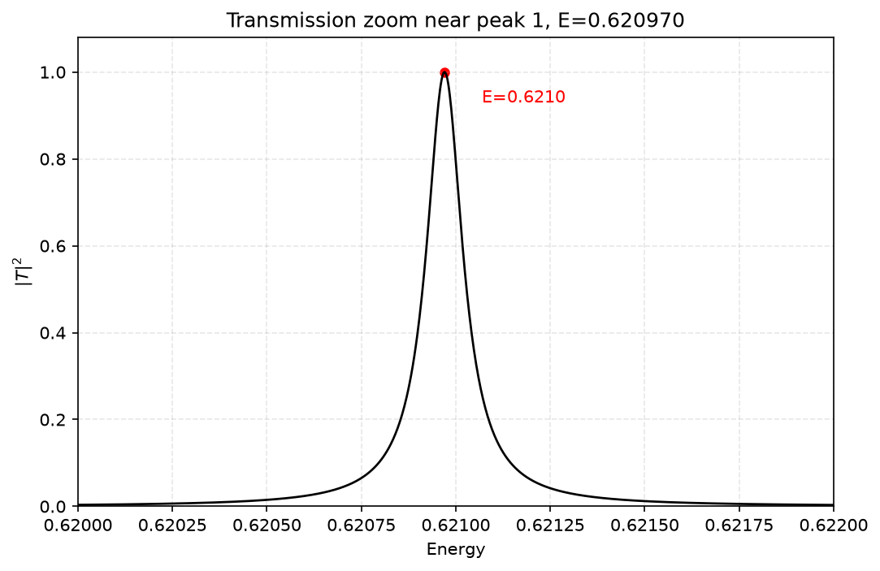
Figure 7. Zoom of the first transmission resonance peak.
A very small change in energy around E₁ ≈ 0.62097030 produces a large change in transmission. This shows that the first resonance is extremely narrow.

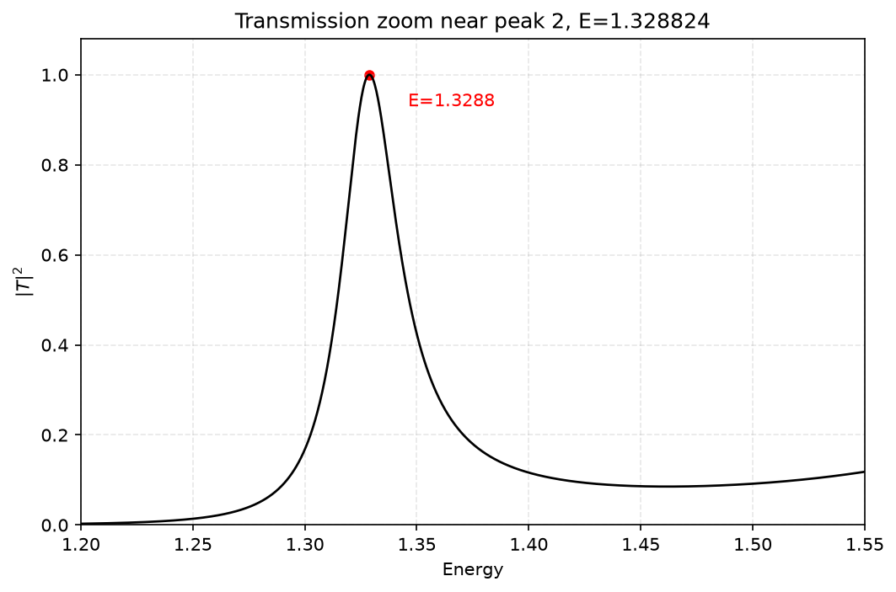
Figure 8. Zoom of the second transmission resonance peak.
The second peak is centered at E₂ ≈ 1.32882395. Compared with the first resonance, the peak is much broader.

3.2 Continuum wave functions around the two resonance peaks
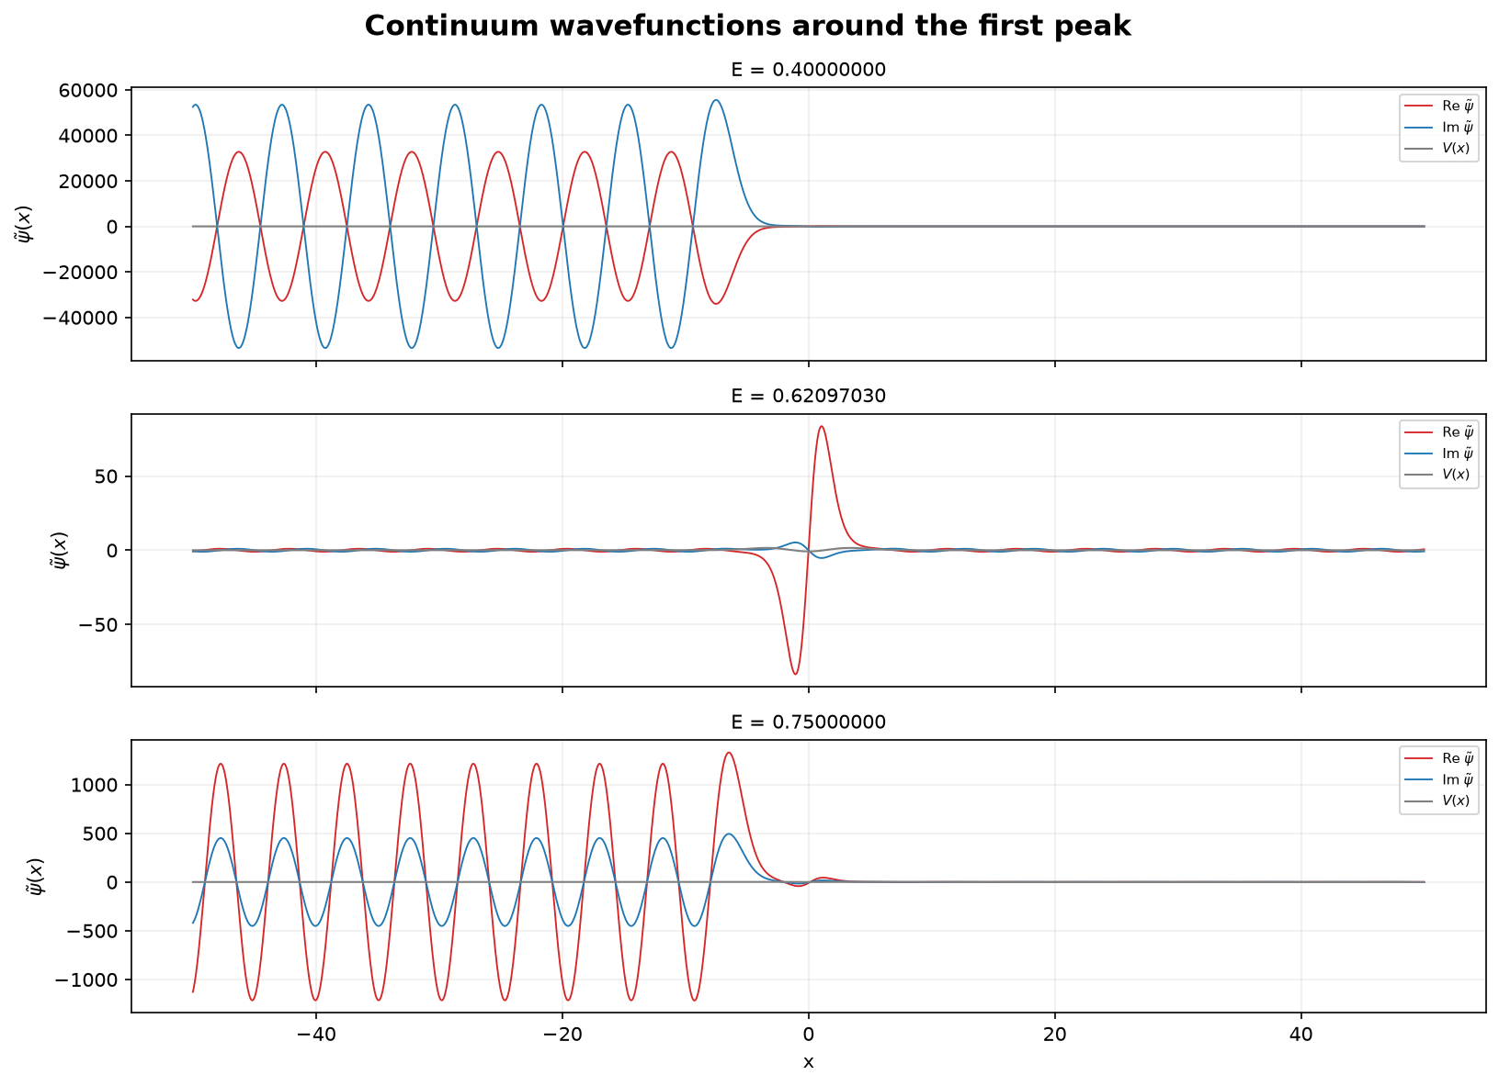
Figure 9. Wave functions around the first resonance peak.
First resonance. For E=0.40 and E=0.75, the wave is mainly reflected because the transmission probability is close to zero. At E≈0.62097030, the transmission rises to nearly one, so the wave passes through the potential almost completely. The resonance is also accompanied by a pronounced oscillation inside the central well.

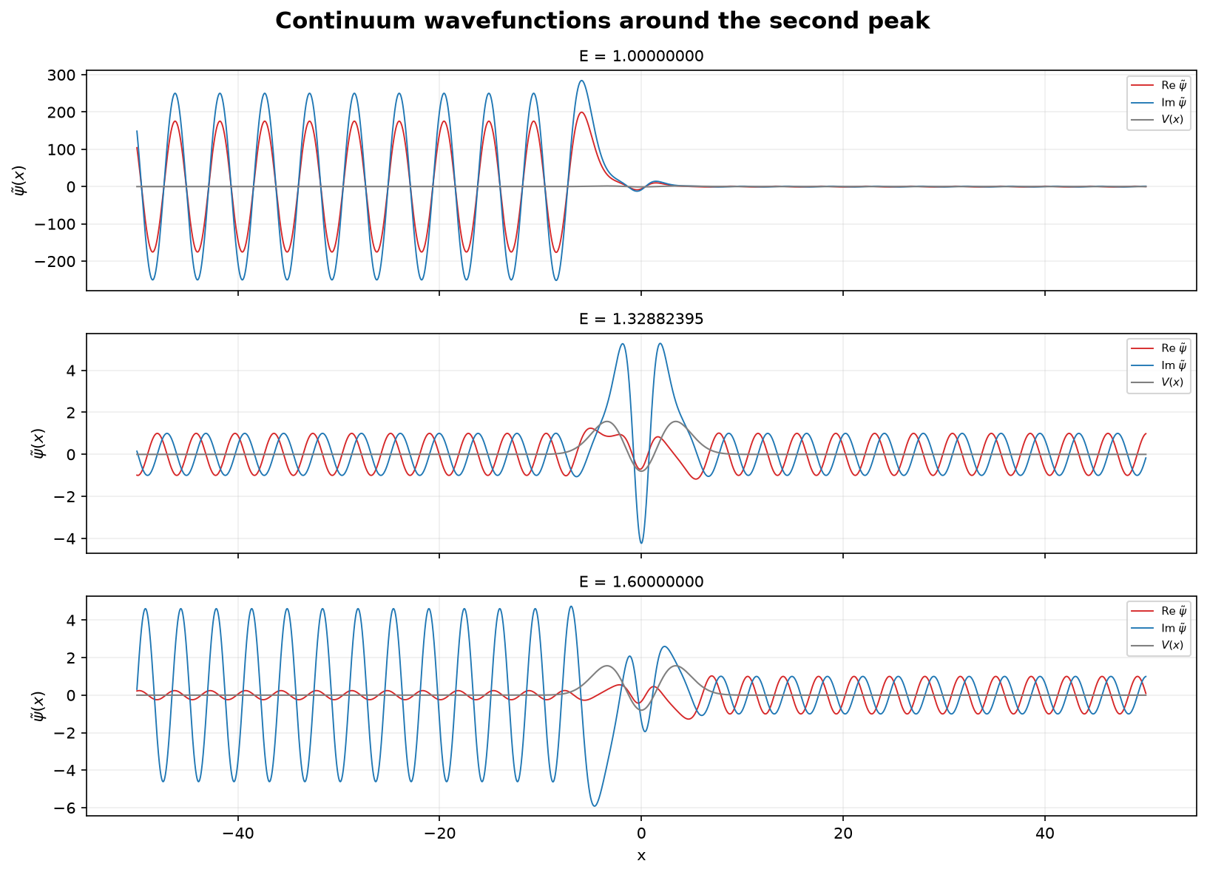
Figure 10. Representative raw continuum states around the second resonance.
Second resonance. At E=1.00 and E=1.60, the transmission is lower and a significant part of the wave is reflected. At E≈1.32882395, |T|²≈1, so the wave is transmitted almost completely through the potential. A pronounced oscillation also appears inside the central well.

Part 4 — Time-dependent scattering wave packets
The time-dependent wavepacket is constructed by adding the stationary scattering states from Part 3 with a Gaussian momentum distribution. Different momentum ranges are then chosen to demonstrate blocked, partially blocked, and pass cases.
Ψ(t,x) = ∫ dp Φ(p) ψp(x) exp(−i p²t/2).
The Gaussian coefficient is calculated from the incident wavepacket,
Φ(p) = 1/√(2π) ∫ dx Ψ(0,x) exp(−ipx).
Here Φ(p) gives the weight of each momentum, ψp(x) is the left-incident stationary scattering state calculated in Part 3, and exp(−ip²t/2) gives the time evolution of each momentum component. Therefore, the chosen momentum range determines which part of the transmission spectrum contributes to the wavepacket.
In the figures, a0 is the momentum uncertainty. The figures also show √2 a0, which corresponds to the width parameter of the momentum-space Gaussian amplitude Φ(p).

4.1 Blocked
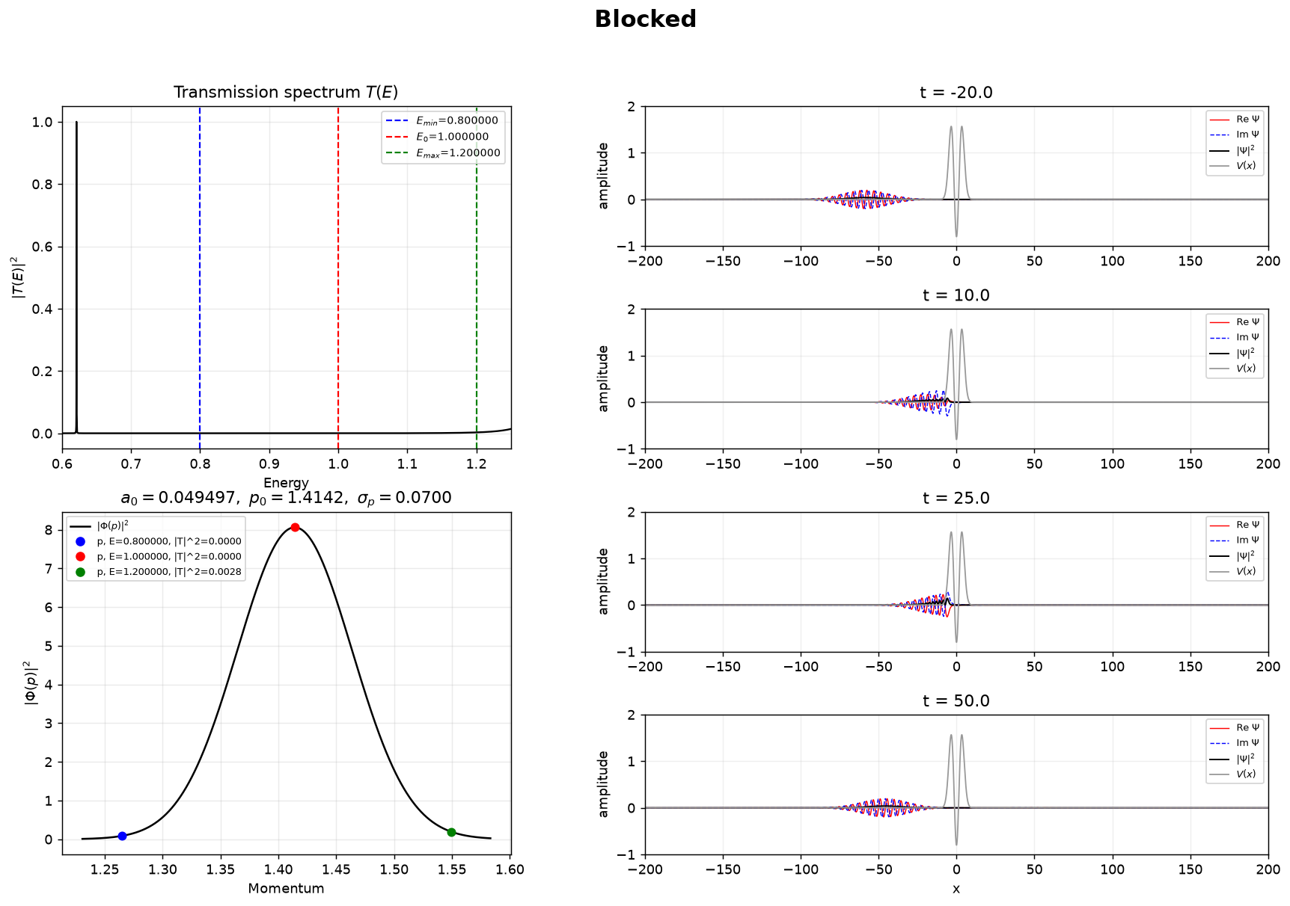
Figure 11. Blocked wave packet: E = 0.8–1.2, centered at E₀ = 1.0.
Almost the whole momentum distribution therefore lies in a low-transmission region. The packet approaches the potential and almost all of the packet is reflected.

4.2 Partially blocked
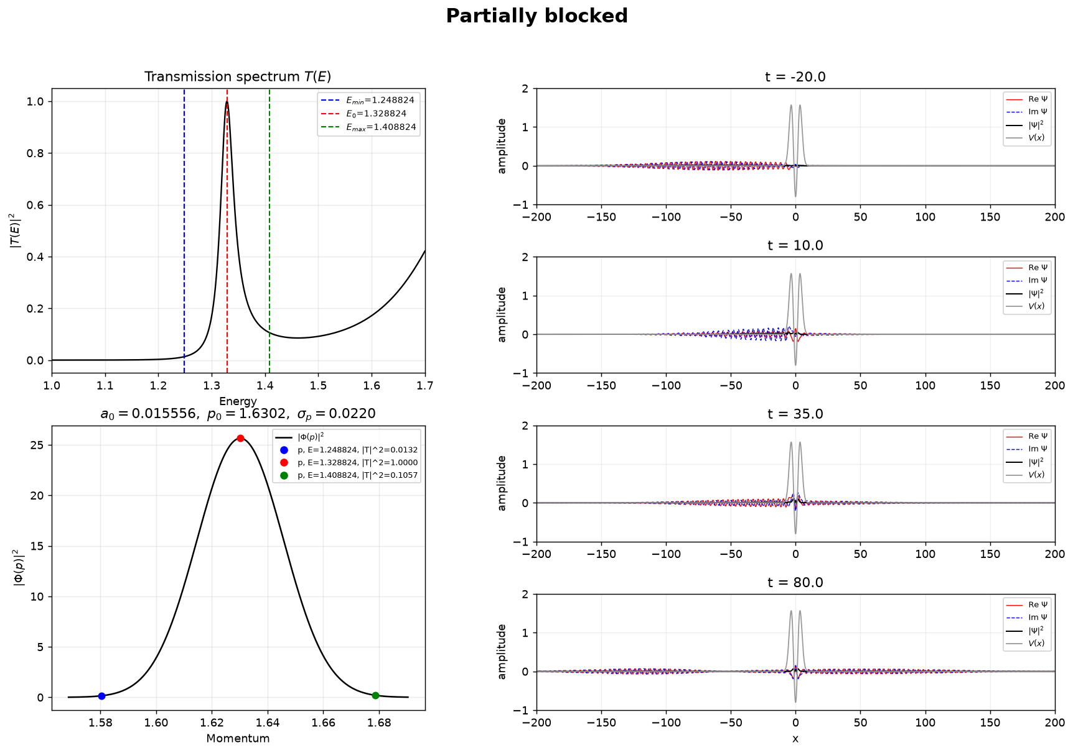
Figure 12. Partially blocked packet centered at the Part 3 second peak, E₀ = 1.32882395.
The center energy is exactly the Part 3 finite-difference value E₂=1.32882395, where the transmission is almost one. The edge markers have transmission probabilities of about 0.013 and 0.106. Because this wider packet contains both high- and low-transmission components, it separates into transmitted and reflected parts.

4.3 Pass
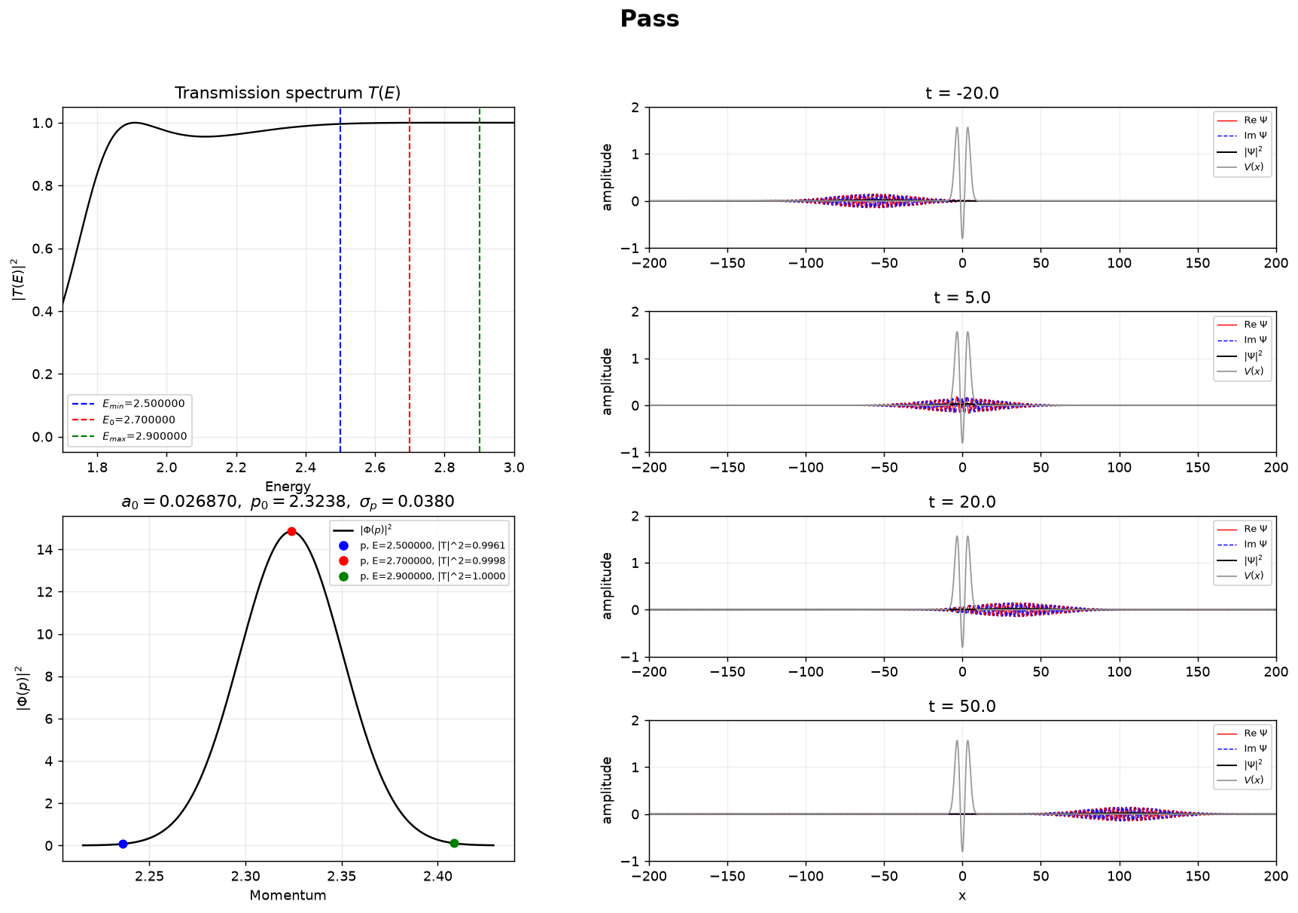
Figure 13. High-energy packet: E = 2.5–2.9, centered at E₀ = 2.7.
Across this interval the transmission probabilities are all almost 1. The wave packet therefore passes through the potential almost completely, with nearly no reflected part.

4.4 Narrow packet around the first resonance
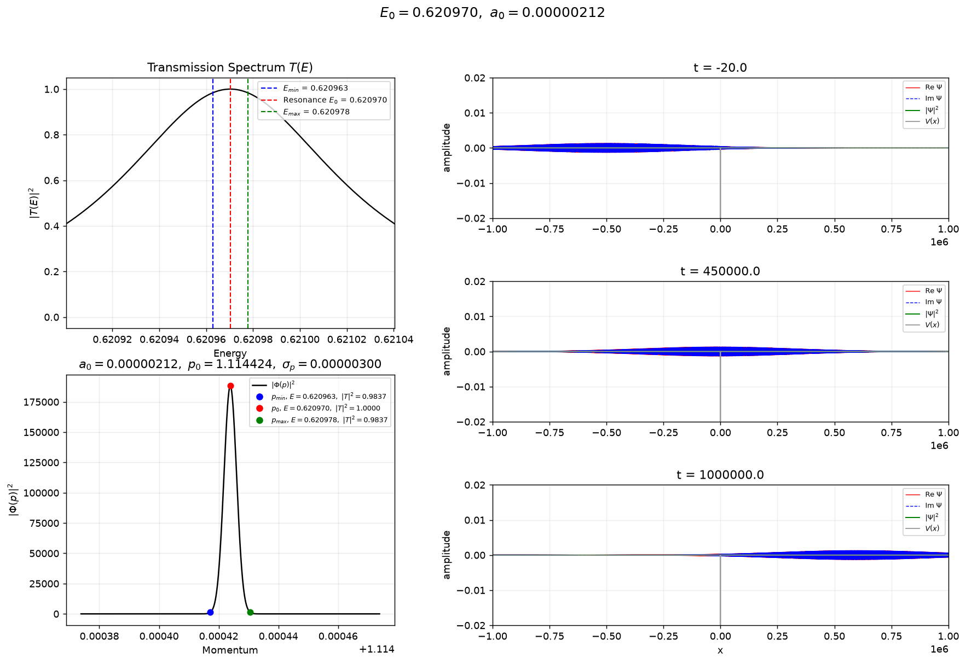
Figure 14. Narrow packet centered at the Part 3 first peak, E₀ = 0.62097030.
The calculation is centered at the first resonance, E₀ = 0.62097030, and uses an extremely small momentum width because this resonance is very narrow. Nearly all spectral components have transmission close to one, giving an integrated transmission probability of about 0.9984. The very small momentum width also makes the packet very broad in real space.

4.5 Narrow packet around the second resonance
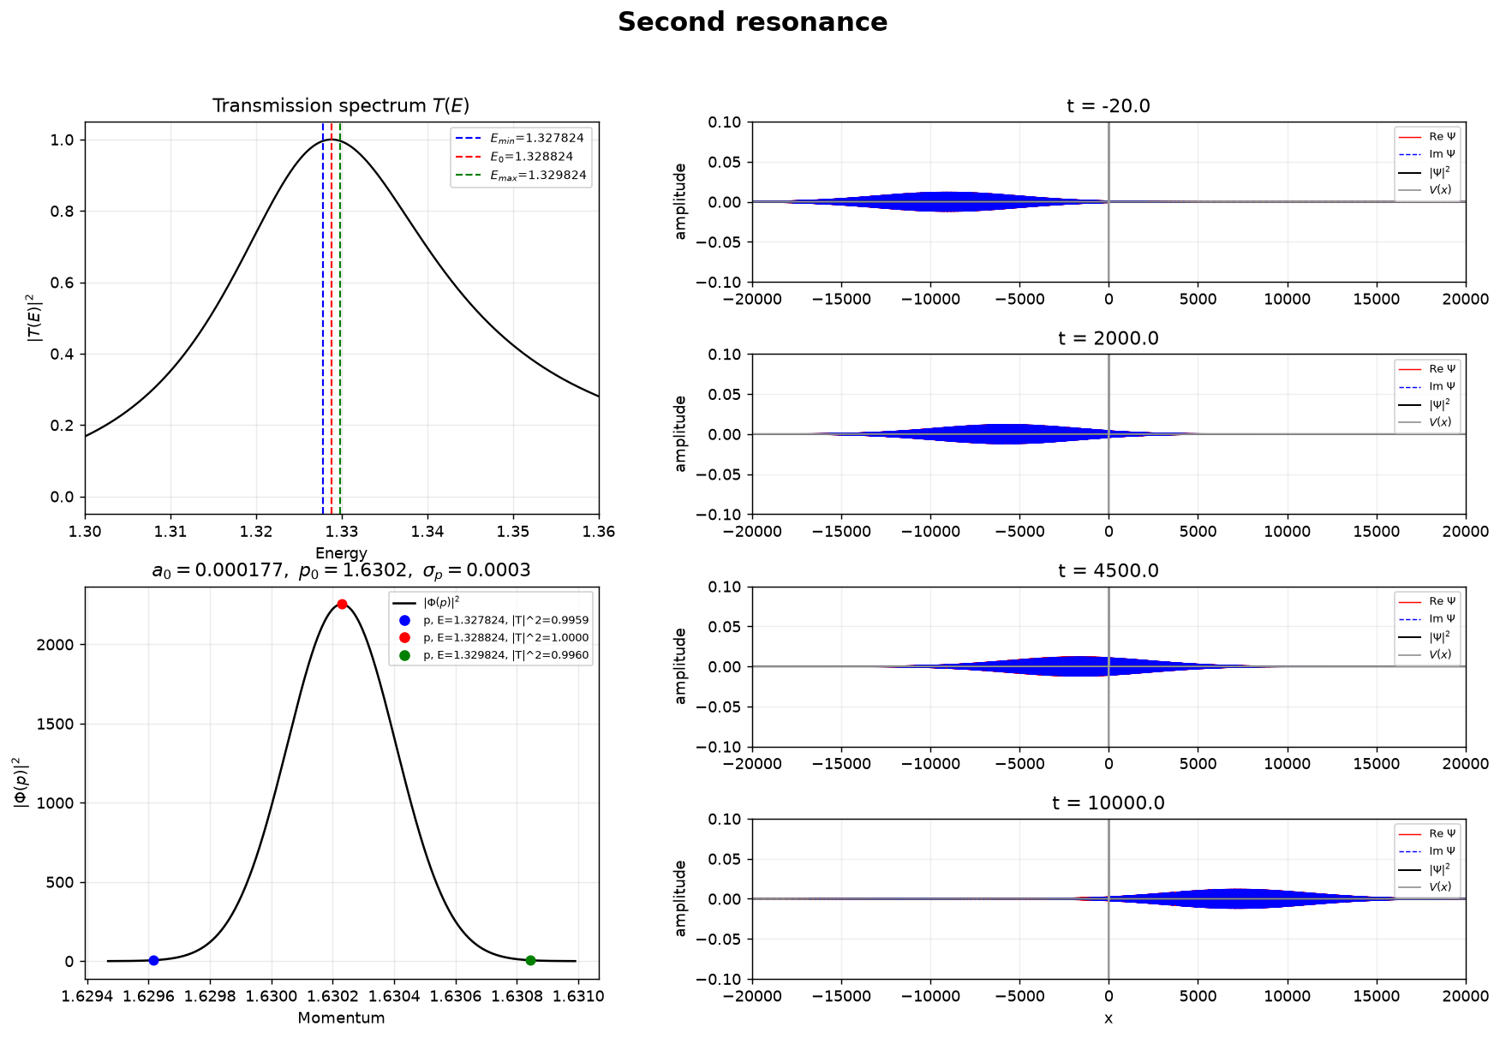
Figure 15. Narrow packet centered at the Part 3 second peak, E₀ = 1.32882395.
This calculation is centered on the same finite-difference value E₂=1.32882395 and uses a very narrow energy window. Nearly all spectral components have transmission close to one, and most of the wave passes through the potential. The very small momentum width also makes the packet very broad in real space.

Part 5 — Box-basis matrix calculation
The stationary Schrödinger equation is also solved in a finite box by expanding the wave function in a sine basis. The basis function used in the calculation is
φ_{j}(x) = √(2/L) sin[jπ(x + L/2)/L], j = 1, 2, …, J.
The wave function is written as
ψ_{n}(x) = ∑_{j=1}^{J} c_{j}^{(n)} φ_{j}(x).
For m=ℏ=1, the Hamiltonian matrix is
H_{ij} = j²π² δ_{ij}/(2L²) + ∫_{−L/2}^{L/2} φ_{i}(x)V(x)φ_{j}(x) dx.
After the Hamiltonian matrix is constructed, numerical diagonalization gives the energies and eigenfunctions. Here J is the number of basis functions, L is the length of the box, and N is the number of x points. The harmonic oscillator is first used to test the method, and then the same calculation is applied to the short-range potential from Part 3.

5.1 Harmonic-oscillator validation
The harmonic oscillator V(x)=x²/2−0.8 is first used to test the method.
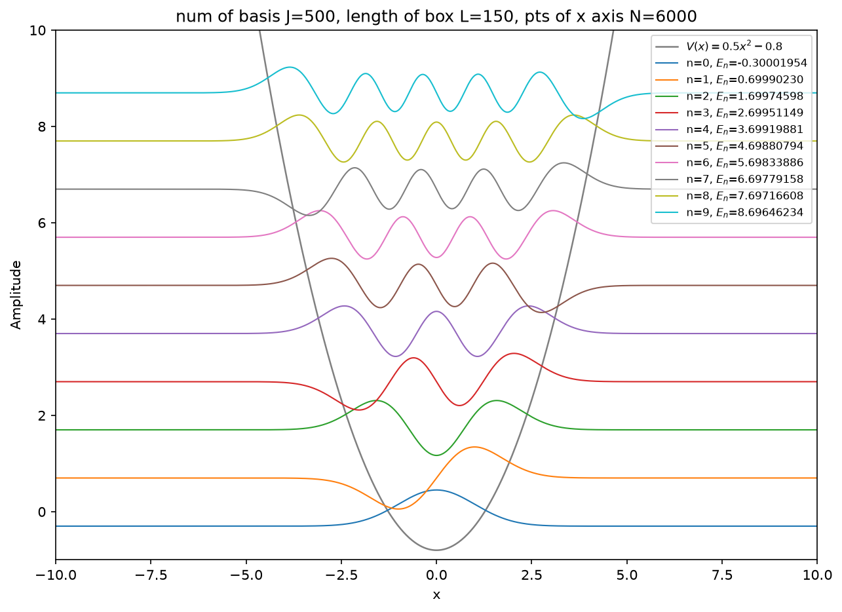
Figure 16. First ten harmonic-oscillator eigenstates obtained with the sine-box basis.
The first ten numerical energies agree with the exact values Eₙ=n−0.3, from −0.3 to 8.7. This shows that the box-basis matrix calculation gives the expected spectrum.

5.2 First 11 short-range eigenstates
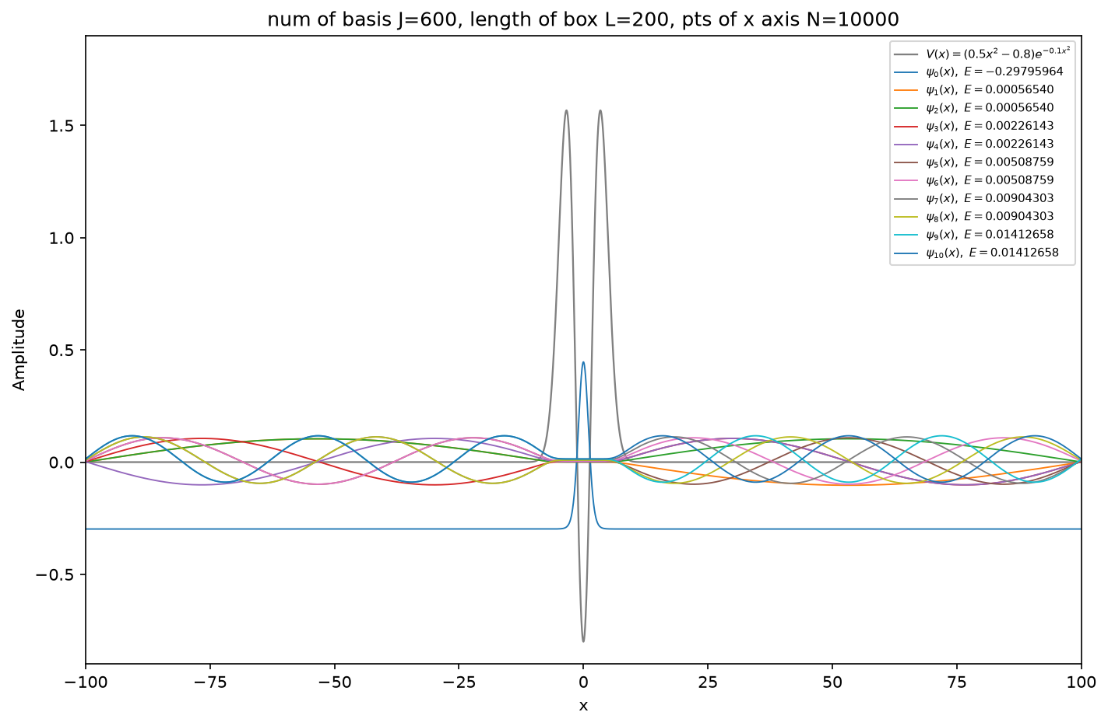
Figure 17. First 11 eigenstates of the short-range potential shown together.
The lowest energy is E₀≈−0.29795964, and this wave function is localized around the central well. The other ten states have small positive energies and extend over the finite box. Therefore, the lowest state is a bound state, while the positive-energy states are discretized continuum states.
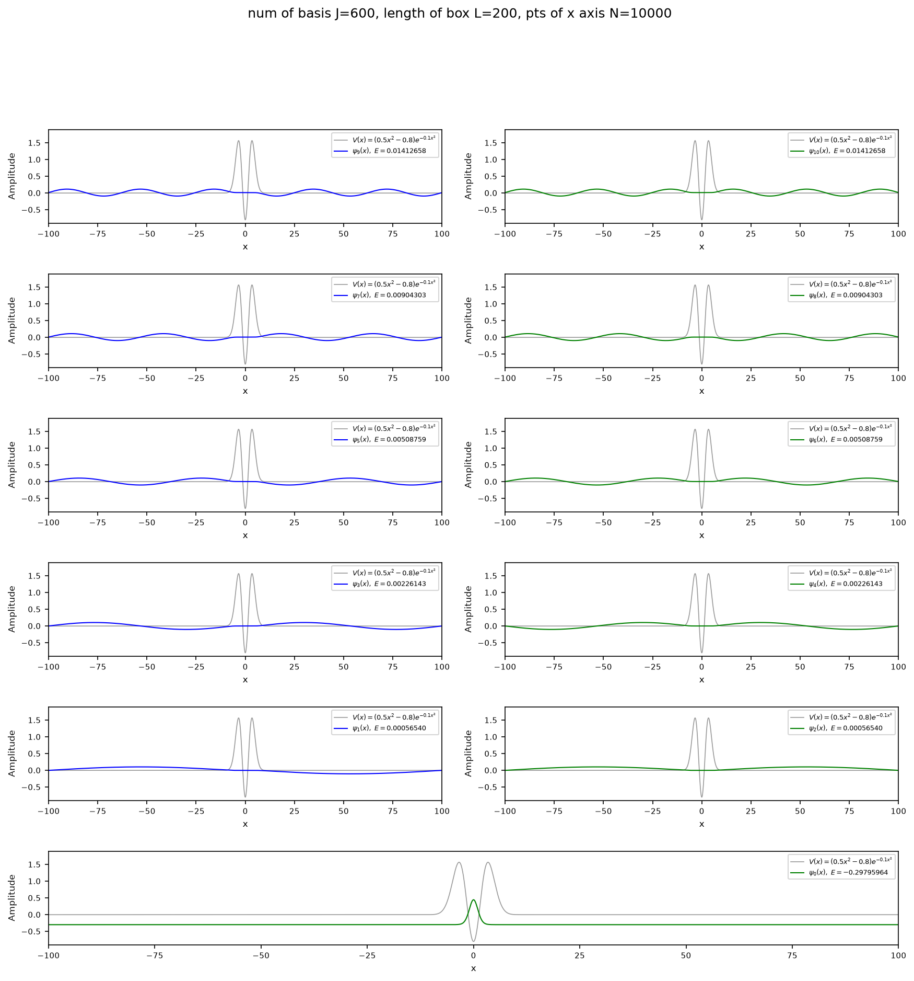
Figure 18. First 11 eigenstates of the short-range potential shown separately.
The separate panels show the shapes of the same 11 states more clearly. As the energy increases, the wave functions have more oscillations over the box, while the bound state remains localized near x=0.

5.3 All box states
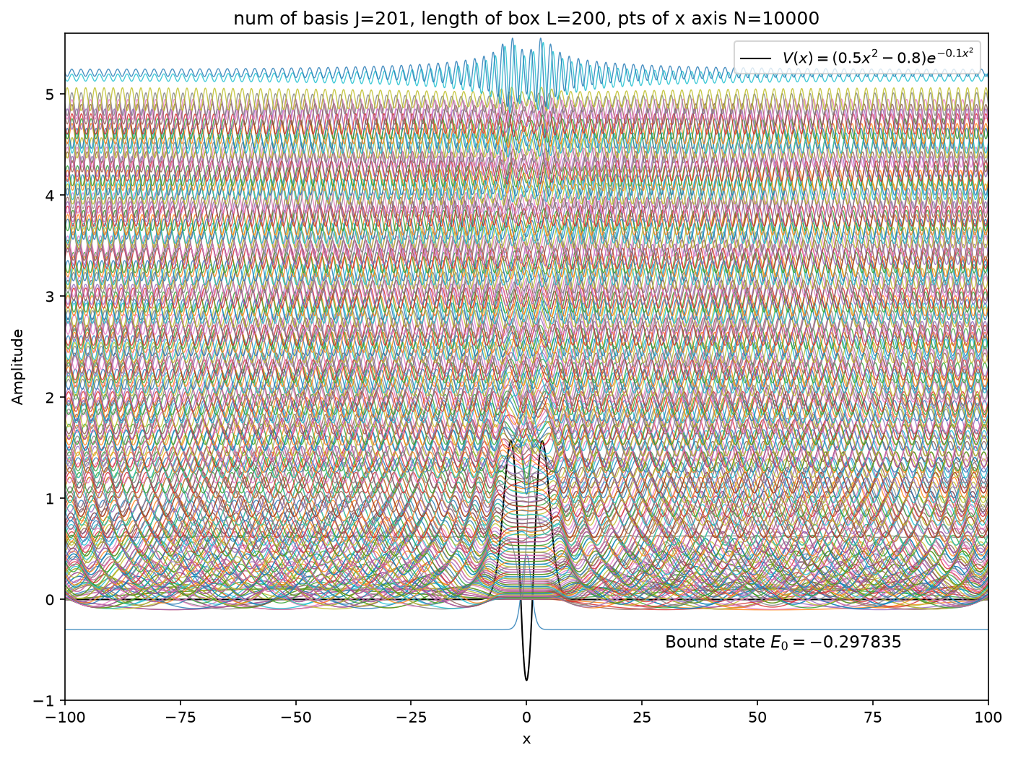
Figure 19. All 201 box eigenstates of the short-range potential.
Only the lowest state has negative energy. The many positive-energy states form a dense set because the finite box changes the scattering continuum into discrete box states. The negative-energy state is separated from them and is the only bound state.

5.4 Bound state and box states near the resonances
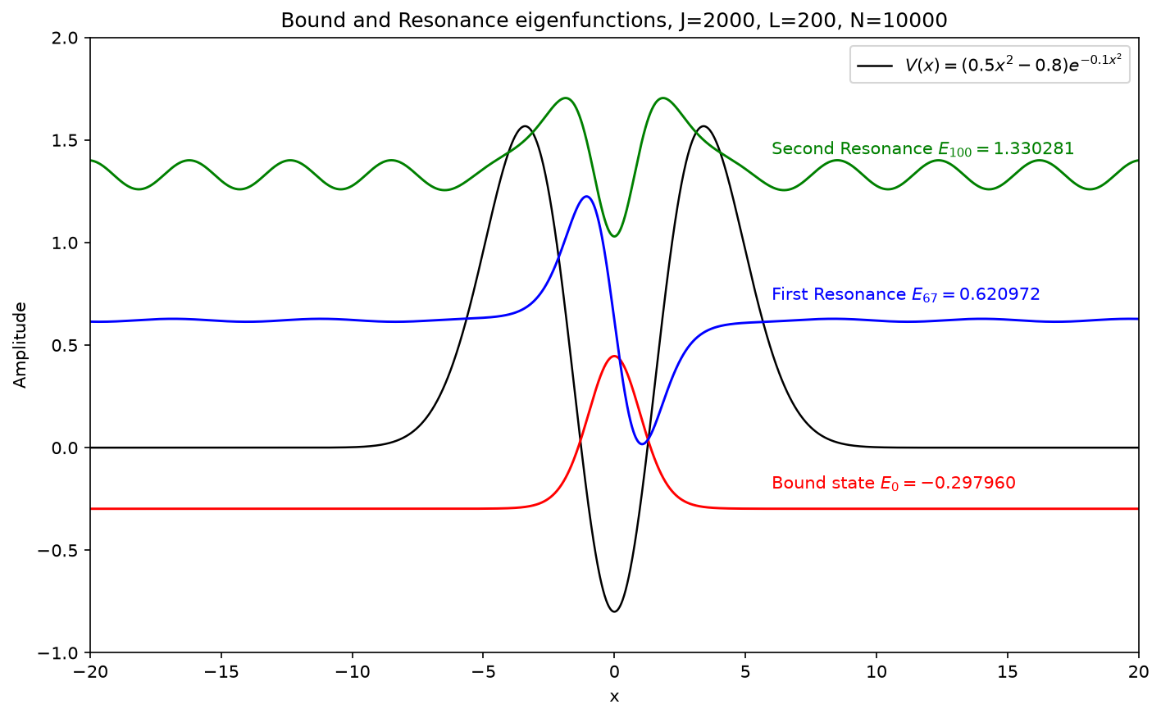
Figure 20. Bound state and two positive-energy box states near the Part 3 resonance energies.
The selected box states are n=0, 67, and 100, with energies E≈−0.29795964, E≈0.62097222, and E≈1.33028105. The two positive-energy values are close to the Part 3 resonances E₁≈0.62097030 and E₂≈1.32882395. Thus, two positive-energy box states are found close to the resonance energies obtained in Part 3. The state near the first resonance is more concentrated around the central well, while the state near the second resonance extends more strongly outside the barriers.
The two positive-energy states are not true bound states because their wave functions still extend outside the barriers. Their exact energies also change when the box length is changed.

